# CS 255 System Design Document Template

## UML Diagrams

### UML Use Case Diagram

I made a few updates to my Use Case Diagram based on suggestions from other students during the Module Discussion. I am unsure of how to best capture the Generate and View/Print Schedule, so I left it as is. Major updates include the addition of the DMV as an Actor, as well as the DMV updating regulations which extends the Update Online Training. Additionally, I added color to the Diagram and added a key. 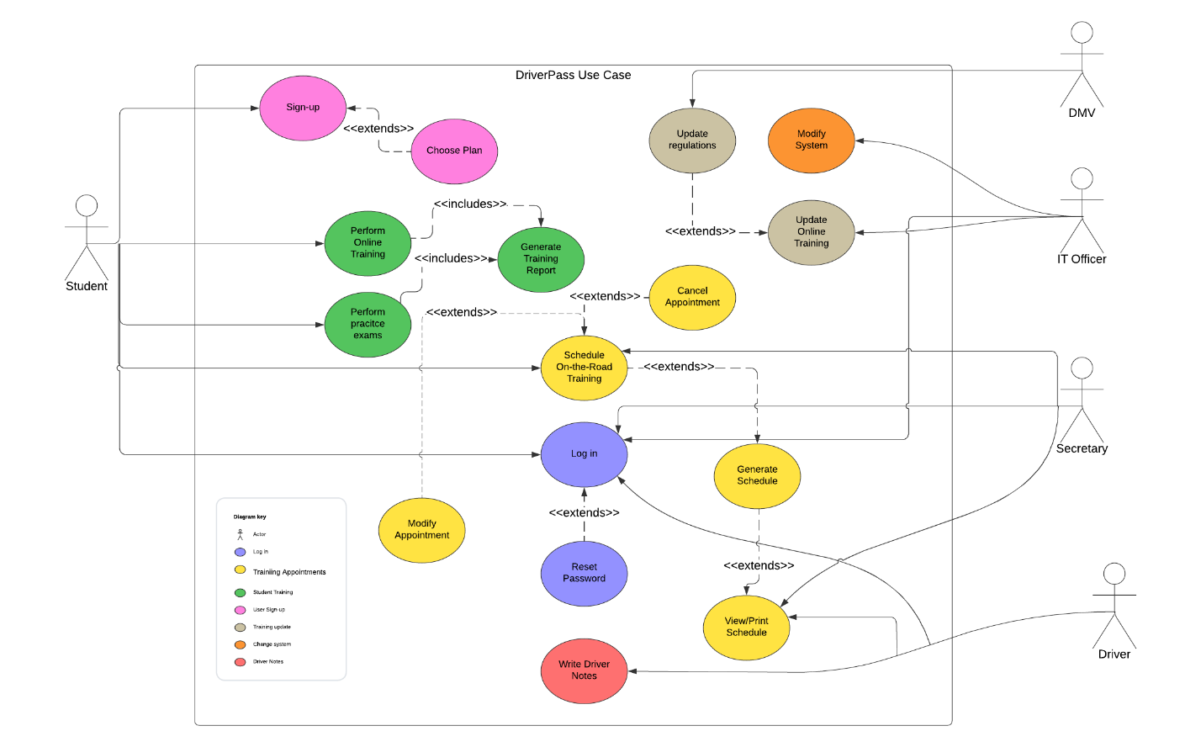

### UML Activity Diagrams

Attached is an Activity Diagram for Scheduling as well as the performance of Online Training. In the Scheduling diagram the User is presented with a choice of Date, if the date is unavailable, they will be asked for another date. To simplify this and increase user experience we can create a monthly calendar with available dates in white, unavailable dates greyed out. Once the individual chooses a Date, they will be asked for a Time. Again, we can increase user satisfaction by having the individual select the time from a dropdown menu. If the Time is not available, the User will be taken back to select a different time. Once a Date and Time are confirmed, the system will attempt to assign a Driver, starting with the Drivers with the least amount of assigned work for the week. If it is unsuccessful, as in that driver is previously scheduled, the system will select the next available Driver. Once this process is complete, the system will generate the schedule and make it available for View/Print. This process will work the same way for modifying the appointment. Canceling an appointment will start at Generate Schedule, at which point the Date and Time will be made available for future appointments.

In the Online Training Activity Diagram, the User will select whether they want to perform a Practice Exam or a Training Module. Upon completion of a Training Module, it will update the User’s Training Jacket and publish the training to the individual’s Profile. If the individual elects to perform a Practice Exam, following completion the individual will have their score displayed and recommended Training Modules based on exam weaknesses. The system will save the score, update the Training Jacket, and publish the score to the individual’s Profile.

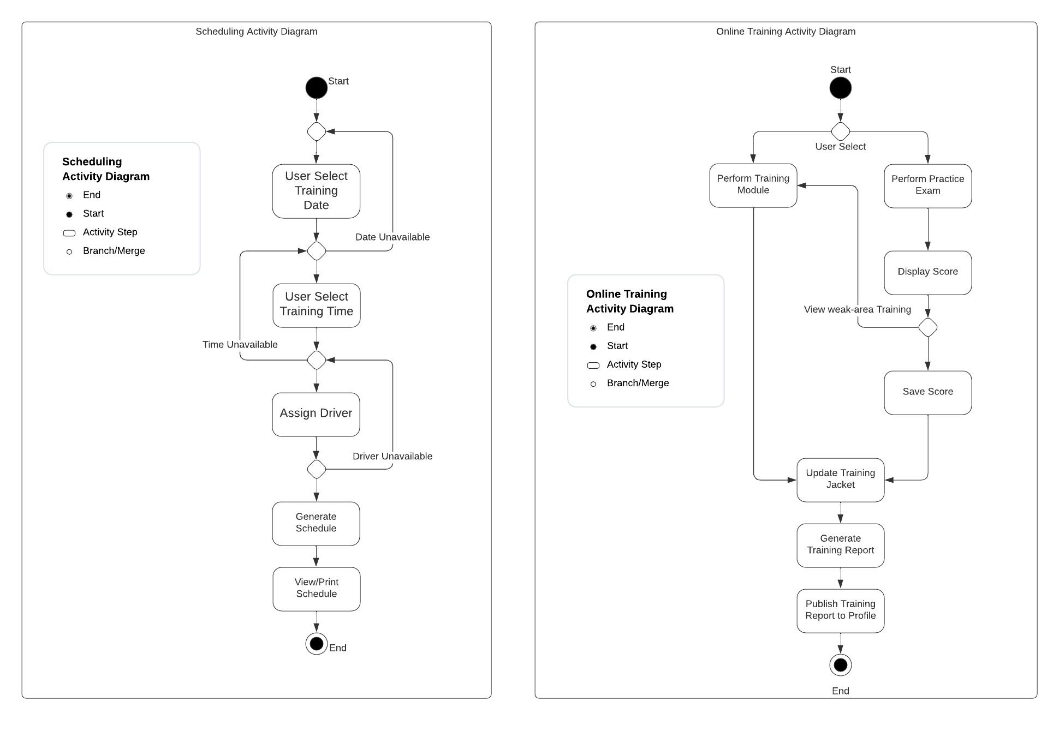

### UML Sequence Diagram

I found this to be difficult, so I am hoping that I completely captured my ideas. I decided to create an Expected Student Training Sequence Diagram in order to further explain my thought process and describe how I would expect a majority of students to interact with the training programs. This sequence will begin with the student selecting a Training Module. Above I stated that the student can start by performing a Practice Exam, in which case the interaction with the first iteration of Training Module will be skipped. Additionally, the sequence diagram assumes that each step is completed successfully. For instance, it does not cover the case in which the student’s training is not successfully updated. The diagram also makes the assumption that the student performs each of the “recommended” steps. The student may not be required to reperform the weakness area modules, but the diagram assumes that they will.

The general sequence is as follows:

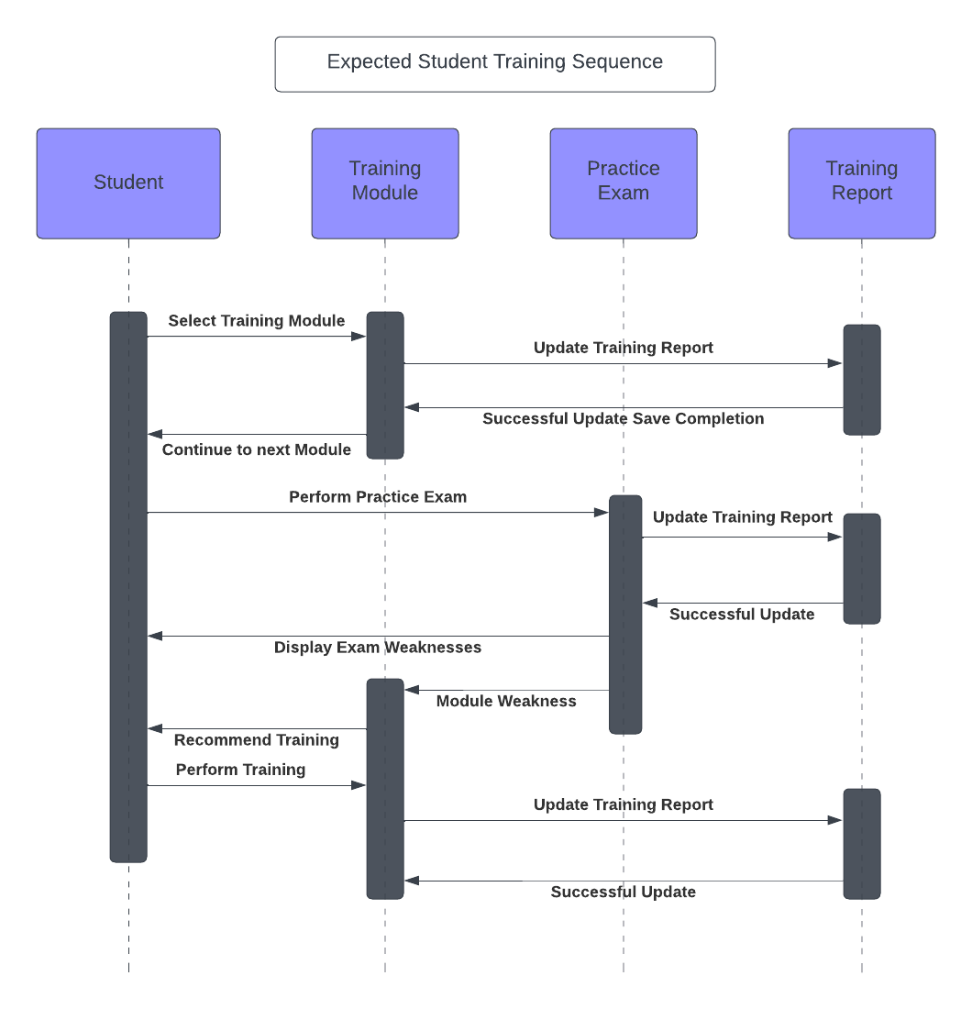

### UML Class Diagram

Attached below is the DriverPass UML Class Diagram. It is not all-encompassing. As with every other diagram, there could be additional information added and, in the real world, I would have multiple individuals review it prior to finalization. The Menu class is meant to be the powerhouse of the diagram and is the main hub where most other actions will take place. This class contains the general menu as described in the Interview and gathers information from the Login to ensure that the individual is shown the appropriate menu once they are at that page. The Login will require an ID and a Password, both of which are created by the individuals during account setup. Employees and Students will have different profiles as the Drivers and Secretaries will not have training to perform. The Schedule is also attached to the main menu, giving both Students and Secretaries the ability to create, modify, or cancel an appointment.

Each of the classes have listed attributes that I could come up with based on the Interview Transcript. There may be additional attributes or methods that are not listed on this diagram. Again, I would recommend an additional individual or individuals review the diagram prior to finalization. This diagram will act as the first iteration of its creation.

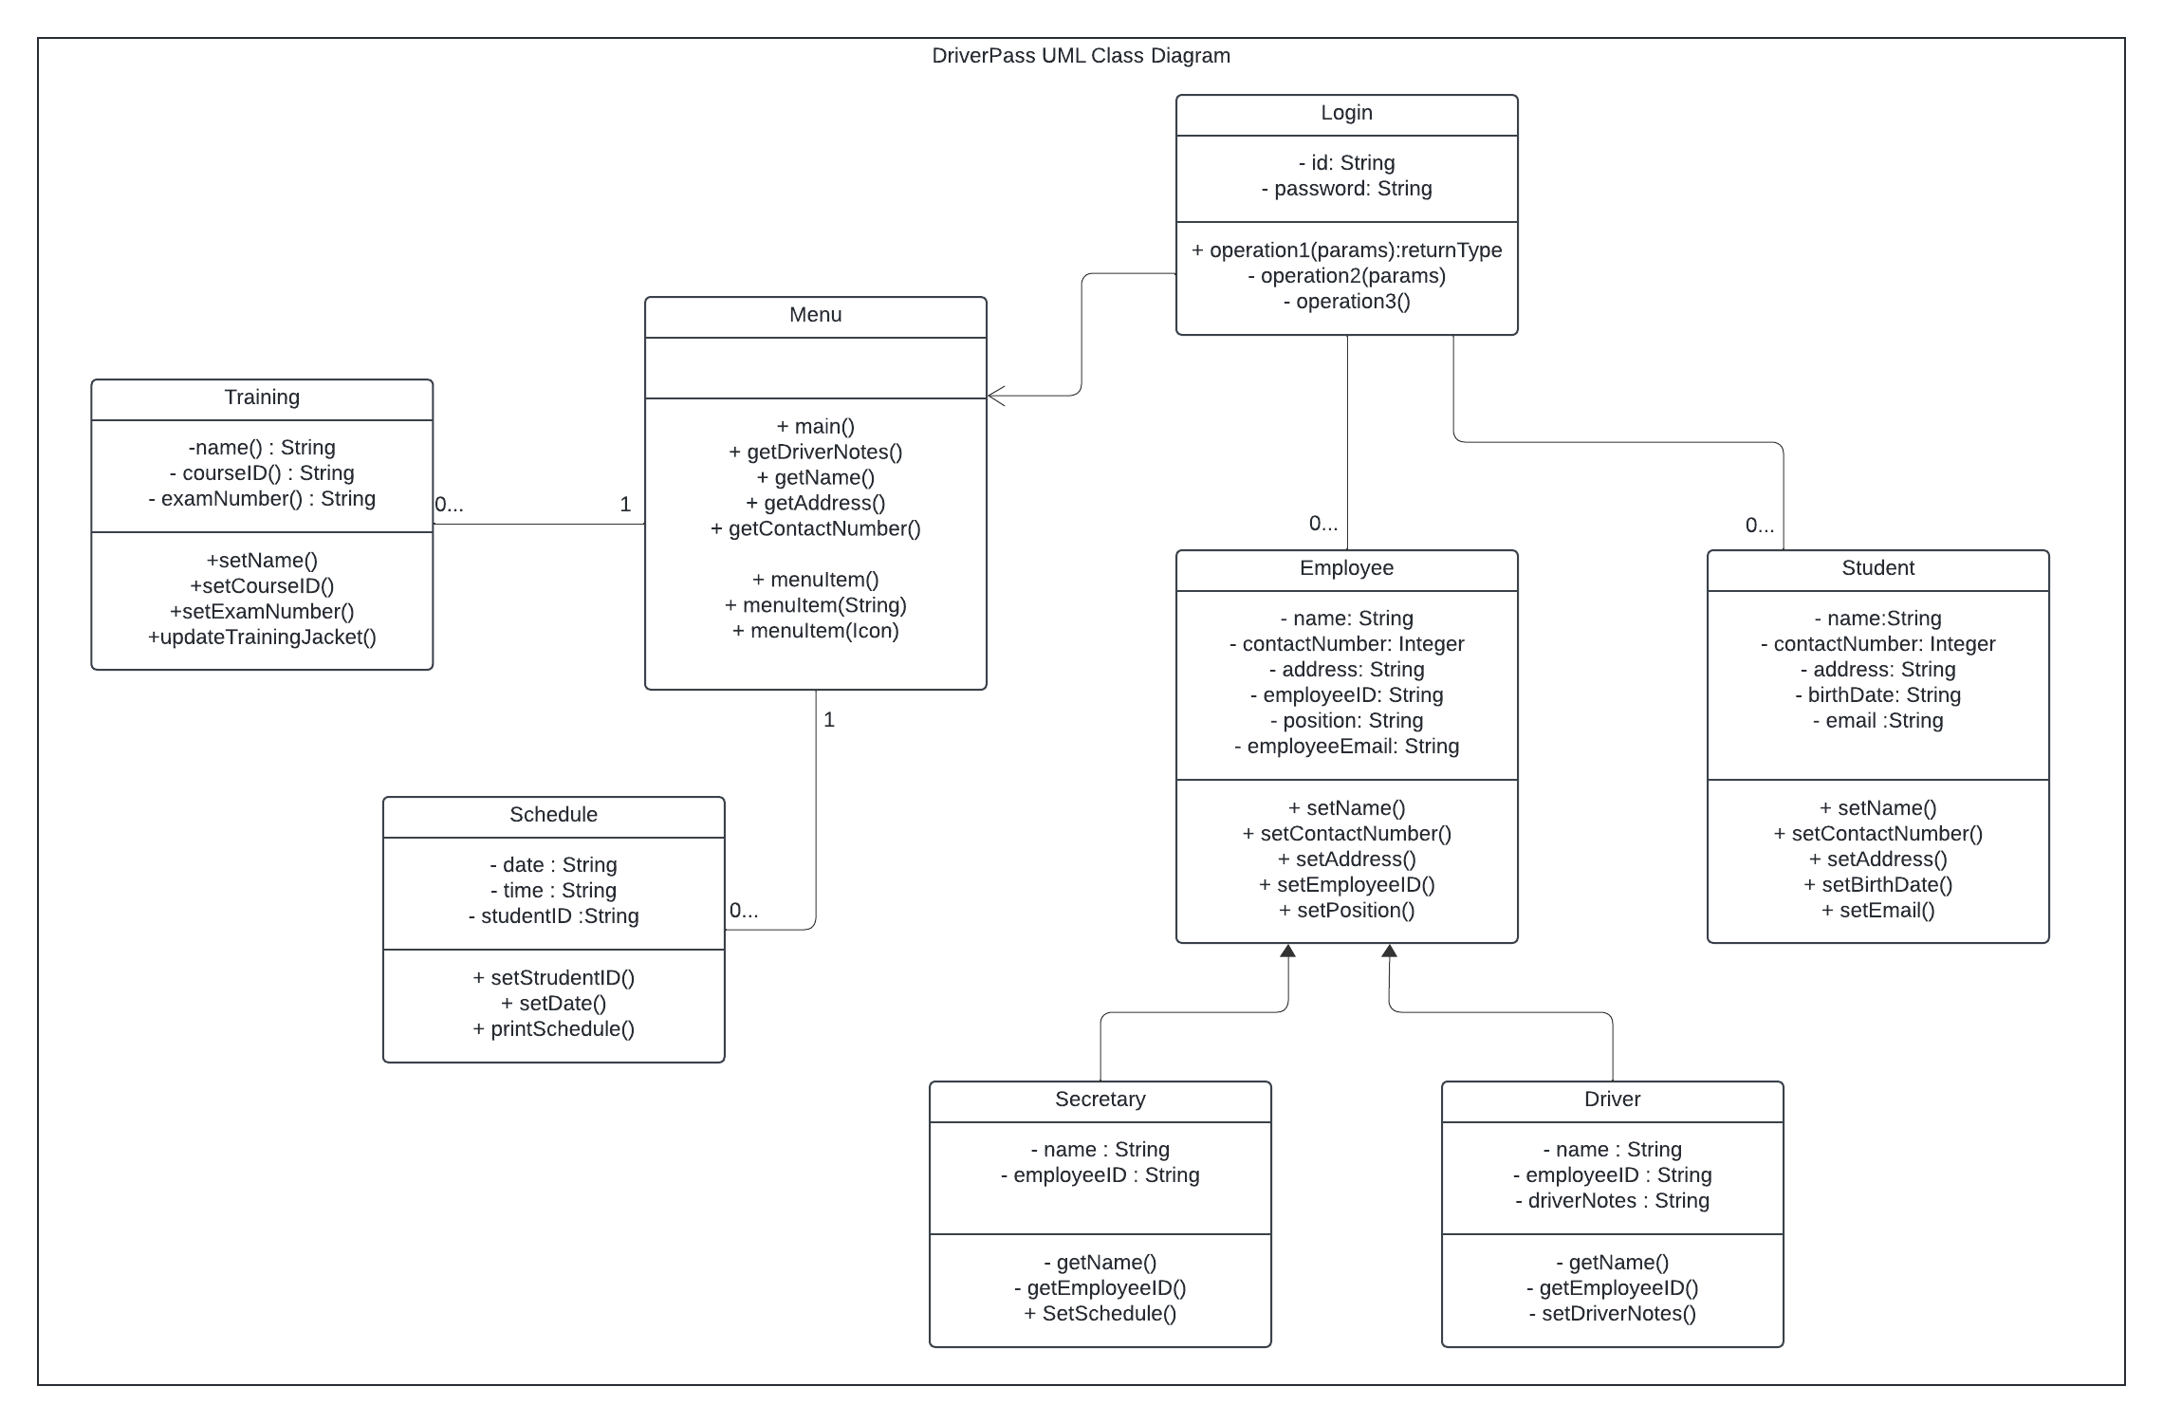

## Technical Requirements

Based on both the Interview Transcript and the Diagrams created above, the system should be created in the cloud. This means that the system will be maintained on servers away from the company headquarters. In order to access the system, individuals will need a reliable connection to the internet, and a source to access the system. To reach as many individuals as possible, the system should be programmed on Windows, iOS, Linux, and mobile devices. Most modern devices should have no problem when accessing our system to the maximum extent possible.

Security is a priority; we should utilize best security practices while creating the system. We will need to integrate a learning environment tool that will consist of practice exams and training modules. Additionally, we will integrate a credit card payment system that provides ease of use to both the students as well as the company and safeguards both clients’ information. We may need to integrate multiple languages during the programming phase. For instance, we may want to consider writing in Java and Python as well as storing data utilizing SQL.